

Southern California Edison
CS Re-Platform Project

CIM-CS-11 Manage Outbound Request
Customer Interaction Management
Business Process Design
Version 0.10

Table of Contents
1 Business Process Overview 5
1.1 Current Pain Points for Southern California Edison 5
1.2 Responsible Parties 5
1.3 Document Control 6
1.4 Terminology 6
2 Business Process Design 8
2.1 Overview Details 8
2.1.1 Manual Outbound Correspondence 10
2.1.2 Automatic Outbound Correspondence 12
2.1.3 Manual Mass Outbound Correspondence 13
2.1.4 Obtain customer contact information 14
2.1.5 Handling of data files 14
2.1.6 Control Report 15
2.1.7 Correspondence Master Table 15
2.2 Process / Performance Improvement 16
2.3 Prerequisites and Inputs 16
2.4 General Assumptions 16
2.5 Business Process Hierarchy 16
2.6 Process Flows 17
2.6.1 Manual Outbound Correspondence 17
2.6.1 Automatic and Manual Mass Outbound Correspondence 20
2.7 3rd Party and SCE Legacy System Integrations 22
2.8 Data Elements 22
2.8.1 Outbound Correspondence 22
2.8.2 Source Systems and Data Volumes 22
2.9 Cloud for Customer (C4C) Integration 23
2.9.1 Processes 23
2.9.2 C4C Views 23
2.9.3 Activity / BP Contact 23
2.10 Exception Management Requirements 23
2.11 Process Risks and Mitigation 23
2.12 Key Performance Indicators 23
2.12.1 Key Metric Definition 24
3 Controls, Regulatory Rules, and Security 25
3.1 Security Considerations 25
3.2 Custom Program/Transaction Codes 26
3.3 Custom Table/Transaction Codes 26
3.4 Data Criticality and Cybersecurity Baseline Risks 26
4 Technical Considerations 28
4.1 RICEF-W Assessment 28
4.1.1 Reports 28
4.1.2 Interfaces 28
4.1.3 Conversion 28
4.1.4 Extension/Enhancements 29
4.1.5 Forms 30
4.1.6 Workflows 30
4.2 IDEX Considerations 30
4.3 Production System Cut-over Considerations 30
4.6 Other Considerations 30
5 Change Management 31
5.1 Change Impacts 31
6 Requirements 36

This page intentionally left blank

Business Process Overview
This document defines the process to manage outbound correspondences that are sent to a Business Partner. All outbound correspondence can be sent to customer via email, voice call, SMS, TTY or U.S. Mail.
All Outbound correspondence can be sent to a BP automatically based on logic and triggers in the system or manually by a user triggering the communication to be sent. OpenText and Nuance will be used for sending outbound communications to BPs. OpenText allows a user to generate ad hoc communications to BPs via the different channels mentioned above. Nuance will be used to send communication to customer via email, voice call, SMS and TTY. GO3 (print services) will be used to send communication to customer of type US Mail.
Outbound correspondence will be integrated with OpenText for retrieving the OpenText document template, content editing, and channel selection. The correspondence image will be stored in OpenText xECM (Extended Content Management) automatically when the correspondence is composed via Opentext. xECM allows user to view the correspondence image via Hybris C4C and S/4HANA. Refer to BPD CIM-CS-09 - Manage Inbound Request for more information on xECM. A BP Contact in S/4HANA will be created by OpenText/Nuance automatically for each communication sent to a BP including the authorized persons for the BP. A user of the system will be able to view all communications sent to a BP via Hybris C4C and S/4HANA.
A control report in S/4HANA and OpenText/Nuance will be made available to reconcile the number of correspondence generated in SAP and the number of correspondence sent from OpenText/Nuance.
Automatic correspondence that are SMS, Voice Call, Email and TTY enabled (e.g. Demand Response notification, Budget Assistance notification and Outage alert), will not be sent to customer from S/4HANA to OpenText. The notification will be sent to customer from S/4HANA to Nuance.
A consolidated master list of all current SCE correspondence can be found in APSE container General Document # 223 Correspondence Master List.

1.1 Current Pain Points for Southern California Edison
- Today, BP email addresses and phone numbers can be stored in multiple systems and there is no existing system process to ensure they are synched up. This results in us having inaccurate contact information and communication preferences.
- BP email address must be entered for each letter. System is not pulling email address from the BP record.
- Inability to send customized letters to a target group, i.e. specific offering/content for each recipient.
- Inability to send customized attachments to a target group, i.e. rate analysis specific to the BP or contact verification request specific to the BP
- Inability to send to BPs by target list (not all BPs sign up for My Account or have email addresses – correspondence can only be sent to BPs that have My Account/email ) A mandated print version is created as a result in addition to My Account/Email
- Resending letters is not possible (letter must be re-created)
- Capturing touch points with BPs. Tracking what and when BPs are receiving communications. (e.g. receiving multiple promotional emails in the same month)
- No central storage of correspondence
- No system controls today to ensure we are not ‘over’ communicating to a BP.
- No system controls to prioritize digital communications that are sent to a BP (e.g., outage alert has higher priority than marketing communication).
- Our current notification systems cannot support sending high volumes of alerts in a timely fashion (e.g., storm conditions requiring high volumes of outage alerts to be sent to BPs)

1.2 Responsible Parties
Contact | Contact Person
Southern California Edison Business Process Owner | Janet Covington
Southern California Edison Lead | Christine Evans
HCL Functional Lead | Adrianus Halim
Solution Architect | Pedro Costa
Front Office or Back Office Lead | Christine Evans
Subject Matter Experts | Janine Aumont  Scott Hirth  Debbie Tillman  Danielle Manzano  Kristen James  Rudy Rodriguez  Araceli Perez  Yumi Takayama
Key User Group | Customer Contact Center (CCC)  Business Customer Division (BCD)  BP Programs & Services (CP&S)  RSO Billing  RSO CAPS

1.3 Document Control
Version | Description of Change | Date | Author
0.1 | Creation of Initial Version | 02/25/2018 | Satyendra Singh
0.2 | Review | 03/05/2018 | Tuan Howe Yap
0.3 | Update based on review | 03/19/2018 | Satyendra Singh
0.4 | Review | 03/21/2018 | Tuan Howe Yap
0.5 | Update Based on review | 03/29/2018 | Satyendra Singh
0.6 | Review | 04/01/2018 | Tuan Howe Yap
0.7 | Update | 04/23/2018 | Tuan Howe Yap
0.8 | Update based on Shalini review | 05/03/2018 | Tuan Howe Yap
0.9 | Update base on Pedro review | 05/08/2018 | Tuan Howe Yap
0.10 | Updated Pedro new comments | 05/10/2018 | Tuan Howe Yap

1.4 Terminology
Term/Acronym | Definition and SAP Equivalent (if applicable)
APSE | Accelerated (or Axon) Project Support Environment
BDEX | SAP add-on functionality to support the processing of BPEM Cases
Billing Cycle | Is a group of contracts to be billed together via date-driven or regional criteria, it controls the billing cycle and is linked to the Meter Reading Unit. SAP equivalent term is the Portion.
Billing Document | A document that outlines the charges incurred for energy consumption for a specific contract. During the process of Billing, a billing document is generated for each contract on a contract account.
BMD | Business Master Data. The BP information which includes personal details, payment terms, dunning levels, billing rates and rate categories. The business master data objects are Business Partner, Business Agreement/Contract Account and Contract.
BPD | Business Process Design (or Document)
BPEM | Business Process Exception Management
BWR | Basic Work Request. SAP equivalent is BPEM.
CA | Contract Account
Channel | Data object in SAP that holds the interval data. Intervals can be kwh, price, factor, etc. SAP equivalent is Profile.
Clarification | A list of payments that could not be processed and require additional work in order to be posted.
Connection Object | Link between installation and postal regional structure. Usually a building, but can also be a piece of property or other facility, such as a fountain or construction site. The connection object corresponds to the functional location in plant maintenance (PM).
Contract | Standard SAP object that is used to link SAP Business Master Data and Technical Master Data through the move-in process
BP | Any entity with a relationship with SCE. This term is usually used in reference to BPs (both individuals and organizations) This can include employees and third party suppliers (banks and payment partners). SAP Equivalent is Business Partner (BP)
EAM | SAP Enterprise Asset Management
Hybris C4C | SAP Cloud for BP Solution
IMG | SAP Implementation Guide – where configuration is performed
Level Pay Plans | SAP equivalent term is Budget Billing. Budget Billing allows BPs to pay regular equal amounts over a yearly period.
Nuance | A 3rd party application that handles sending of correspondence to BP via SMS, email and voice call
OA | Owner Allocation
Premise | Represents one of the SAP Technical Master Data object that is supplied with energy, for example, an apartment or factory. A premise can have several utility installations. The premise is allocated to a connection object and the address of that connection object
Property | Standard SAP object that is primarily used for arranging agreements with the owner concerning automatic move-in. It also stores an owner history for installations that are part of owner allocation process
S/4HANA | SAP HANA 4 Business Suite
SCE | Southern California Edison

Additional terms may be found in APSE General Document # 32 CSRP Glossary

Business Process Design

2.1 Overview Details
This document details the management of outbound correspondence from SCE to Business Partner.
The correspondence management process will be documented for the variants detailed below:
- Manual outbound correspondence.
- Automatic outbound correspondence.
- Mass manual Outbound correspondence (this is documented in detail in BPD CIM-CS-15 Manage Customer Segmentation & Campaign Management)
An outbound correspondence can be created manually by user or automatically by the system. Outbound correspondence can be sent via email, voice call, SMS, TTY or by U.S. mail. The BP communication method preferences for various types of communications (e.g., account alerts, outage, program events and marketing) is stored in BP Preference . Refer to BPD CIM-CS-01 Business Master Data – Manage Business Partner for more information.
When an outbound correspondence is generated by OpenText (manual correspondence of all channels and automatic correspondence with channel of US Mail), a copy of the correspondence image will be uploaded and saved in the OpenText xECM (Extended Content Management) system. Users of the system will be able to to view the correspondence sent to a BP including the delivery results. Refer to BPD CIM-CS-09 - Manage Inbound Request for more information.
A BP Contact will be created automatically by OpenText or Nuance each time a copy of the document image is sent to BP using E-CIM-CS-11 - Auto IR creation for Inbound & Outbound Correspondence/Communication. The source of the BP Contact will indicate the BP Contact is Outbound. This is to differentiate the outbound correspondence vs inbound correspondence that is uploaded to xECM.
The diagram below (Figure 1) describes a high level process flow for outbound correspondence using OpenText and SAP referencing the step numbers indicated in the diagram.
When a BP requests a correspondence be sent to them (e.g., CARE application) the user will employ OpenText Empower Editor (1) to construct the correspondence using a predefined OpenText correspondence template.
Automatic correspondence and invoices are generated in S/4HANA (2).
The Manual and Automatic correspondences will undergo formatting in Exstream (3) before it is sent to the BP via multiple communication channels such as US mail, SMS and email (4).
The BP will receive the correspondence based on their preferred communication (5) channel setup in BP Preference. A copy of the outbound correspondence will be uploaded to xECM (6) for storage. xECM is documented in BPD CIM-CS-09 – Handle Inbound Correspondence.
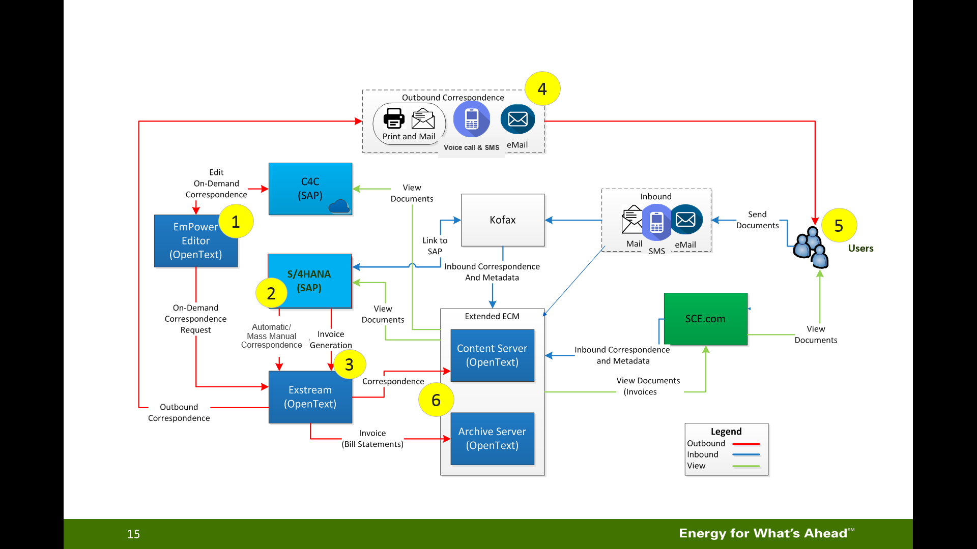
Figure 1: Outbound correspondence process flow

Exstream is the central system hosting the correspondence content and layout. Any correspondence will be sent to Exstream to obtain the correspondence content and under go layout formatting before sending out to the BP or to the contact information defined in the correspondance request (e.g., adhoc communication, confirmation for a specific transaction etc.).

Automatic Correspondence of type email, SMS, voice call and TTY enabled will be sent to customer via Nuance. The correspondence template will be configured in Nuance. S/4HANA will pass the correspondence to Nuance and Nuance will under go layout formatting before sending out to the BP. The diagram below (Figure 2) explains the process flow where the triggering program extracts the list of customers to Notification Engine where data is formatted before passing to External Notification Vendor (Nuance) via Notification Engine. Nuance will then send the Notification to customer based on customer preferred communication channel. A BP Contact will be created when Notification is sent to the customer. The same BP Contact will be updated when the response is received for the Notification. Refer to CIM-CS-09 - Manage Inbound Request for more information about updating the BP Contact. Correspondence sent from S/4HANA to Nuance will not be stored in OpenText archive server xECM because the template is hosted in Nuance.
Figure 2: Notification via Nuance

Outbound correspondences can be sent to the BP via the BPs preferred communication channels; US Mail, SMS, TTY, voice call and email.. Below are the explanations of how correspondence is sent via various channels:

U.S. Mail
OpenText Exstream sends files to SCE print facility at G03 where correspondences will be printed. The files will be uploaded to a G03 file server by Exstream. At the end of the day, G03 personnel will go to the G03 file server and extract the files for printing. G03 personnel manage printing of correspondence to be sent to a BP via U.S. mail. This can include paper applications for programs, the BP monthly bill and any inserts to be mailed with the correspondance.
A copy of the correspondence will be stored in xECM by OpenText and a BP Contact will be created automatically by OpenText using E-CIM-CS-11 - Auto IR creation for Inbound & Outbound Correspondence/Communication.

Email
There will be at least 3 types of email ids that will send out correspondences to the BPs. SCE may keep the existing email ids or email vendor(s) that are currently used.
- There will not be any integration between Exstream and ‘Sales Force’ email server. Sales Force will send out marketing related emails to BP. The email sent out via Sales Force can be stored in xECM by user manually by emailing soft copy of the correspondence to user email inbox and upload to xECM via Outlook.
- OpenText will use the group email ID to send the Outbound Correspondence that currently has a SCE group email id identified (e.g. SCE-OLS@sce.com and CICORR@sce.com). A copy of the email will be stored in xECM and a BP Contact will be created automatically by OpenText using E-CIM-CS-11 - Auto IR creation for Inbound & Outbound Correspondence/Communication.
Email campaigns will be sent out via Hybris Marketing, refer to BPD CIM-CS-15 Manage Customer Segmentation & Campaign Management. A copy of the email will not be stored in xECM.
- For Outbound Correspondence that is not sent via Sales Force and has no SCE group email or account manager identified, a general email ID will be setup and OpenText will use this general email (e.g. SCE_Reply@SCE.COM or NO_REPLY@SCE.COM) to send the rest of the correspondence to the BP.
For Outbound correspondence sent to BPs from Account Managers outlook email without going through OpenText/Nuance, correspondence will not be archived in OpenText automatically, the account manager will document this as an activity record in C4C.
For automatic correspondence, the triggering process such as Rate Change program will generate an XML file and place it in the file server using I-CIM-CS-11 - Interface to send Notification from SAP S/4 HANA to Nuance. The triggering processes will need to be documented in the RICEFW for FORM if they are not already documented in the BPD. Nuance will pick up the file for formatting and send an email to BP if the BP preferred communication channel is ‘Email’. A copy of the email will not be stored in xECM. A BP Contact will be created automatically by Nuance using E-CIM-CS-11 - Auto IR creation for Inbound & Outbound Correspondence/Communication.
For manual correspondence, after user has composed the correspondence, OpenText will send the data to Nuance using I-CIM-CS-11 - Interface to send Notification from OpenText to Nuance. A copy of the email will be stored in xECM and a BP Contact will be created automatically by Nuance using E-CIM-CS-11 - Auto IR creation for Inbound & Outbound Correspondence/Communication.
All outbound correspondence that sent via email will have a privacy notice added to be in compliance with CANSPAM regulations.
Automatic correspondence such as Budget Assistant, Demand Response and Final Call Notice will be sent to customer via Nuance using NO_Reply@SCE.COM as customer does not have the option to reply to these Notifications. NO_Reply@SCE.COM as customer does not have the option to reply to these Notifications.
Automatic correspondence such as an email Outage alert will be sent to customer via Nuance using SCE_Reply@SCE.COM. Customer is able to click on the Power On or Power Off hyperlink in the email by responding if the power is ON or OFF. Refer to CIM-CS-09 Manage Inbound Request for more information. Refer to Section 2.1.9 to 2.1.10 for more information on Budget Assistant, Demand Response and Final Call Notice. SCE_Reply@SCE.COM. Customer is able to click on the Power On or Power Off hyperlink in the email by responding if the power is ON or OFF. Refer to for more information. Refer to Section 2.1.9 to 2.1.10 for more information on Budget Assistant, Demand Response and Final Call Notice.

SMS
For automatic correspondence, S/4HANA will pass the data to Nuance using I-CIM-CS-11 - Interface to send Notification from SAP S/4 HANA to Nuance and Nuance will send correspondence to BP. Triggering process in S/4HANA will extract the data from S/4HANA, pass the XML data structure in a file and store it in the file server for Nuance to process. A copy of the SMS file will NOT be stored in xECM. A BP Contact will be created automatically by Nuance using E-CIM-CS-11 - Auto IR creation for Inbound & Outbound Correspondence/Communication.
For manual correspondence, Nuance will be integrated with Exstream using I-CIM-CS-11 - Interface to send Notification from OpenText to Nuance. Exstream will also store the XML file in the SMS file server for Nuance to process. A copy of the SMS file will be stored in xECM by OpenText. A BP Contact will be created automatically by Nuance using E-CIM-CS-11 - Auto IR creation for Inbound & Outbound Correspondence/Communication.
SMS messages sent to a BP will contain instructions on how the receipant can opt-out of future SMS messages (e.g., text STOP to stop) for that type (e.g., outage alerts) and specific phone number.
The SMS file structure contains all data that needs to be shown on the correspondence including business master data, technical master data and dynamic data (if any).
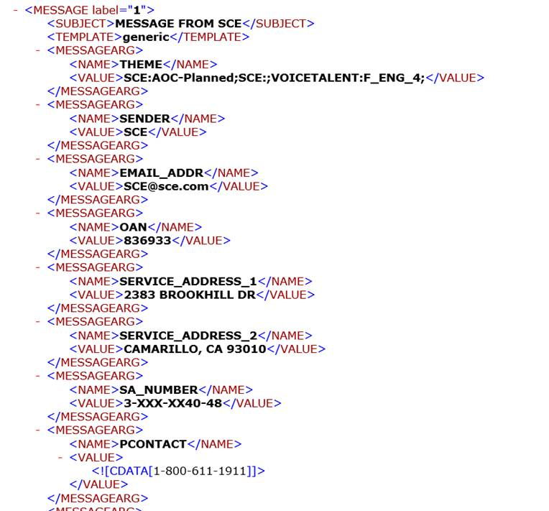
Figure 3: XML data structure

Customer is able to reply to Outage Alert by responding if the power is ON or OFF. Refer to CIM-CS-09 Manage Inbound Request for more information. Refer to Section 2.1.9 to 2.1.10 for more information on Budget Assistant, Demand Response and Final Call Notice.

Voice Call
For automatic correspondence, S/4HANA will pass the data to Nuance using I-CIM-CS-11 - Interface to send Notification from SAP S/4 HANA to Nuance and Nuance will send correspondence to BP. Triggering process in S/4HANA will extract the data from S/4HANA, pass the XML data structure in a file and store it in the file server for Nuance to process. A copy of the voice call text will NOT be stored in xECM. A BP Contact will be created automatically by Nuance using E-CIM-CS-11 - Auto IR creation for Inbound & Outbound Correspondence/Communication.
For manual correspondence, Nuance will be integrated with Exstream using I-CIM-CS-11 - Interface to send Notification from OpenText to Nuance. Exstream will also store the XML file in the SMS file server for Nuance to process. A copy of the voice call text will be stored in xECM by OpenText. A BP Contact will be created automatically by Nuance using E-CIM-CS-11 - Auto IR creation for Inbound & Outbound Correspondence/Communication.
Certain types of voice calls will enable the recepiant to opt-out of future calls, refer to CIM-CS-09 Handle Inbound Request for more information.
Customer is able to reply to the outage Notification by responding if the power is ON or OFF within the voice alert they receive (e.g., press 1 power is on OR press 2 power is still out). Refer to CIM-CS-09 Manage Inbound Request for more information. Refer to Section 2.1.9 to 2.1.10 for more information on Budget Assistant, Demand Response and Final Call Notice.

TTY
For automatic correspondence, S/4HANA will pass the data to Nuance using I-CIM-CS-11 - Interface to send Notification from SAP S/4 HANA to Nuance and Nuance will work with the TTY operator to communicate to customer. Triggering process in S/4HANA will extract the data from S/4HANA, pass the XML data structure in a file and store it in the file server for Nuance to process. A copy of the text will NOT be stored in xECM. A BP Contact will be created automatically by Nuance using E-CIM-CS-11 - Auto IR creation for Inbound & Outbound Correspondence/Communication.
For manual correspondence, Nuance will be integrated with Exstream using I-CIM-CS-11 - Interface to send Notification from OpenText to Nuance. Exstream will also store the XML file in the SMS file server for Nuance to process. A copy of the text will be stored in xECM by OpenText. A BP Contact will be created automatically by Nuance using E-CIM-CS-11 - Auto IR creation for Inbound & Outbound Correspondence/Communication.
TTY messages sent to a BP will contain instructions on how the receipant can opt-out of future TTY messages (e.g., type STOP to stop) for that type (e.g., outage alerts) and specific phone number.
Customer is able to reply to Outage Alert by responding if the power is ON or OFF. Refer to CIM-CS-09 Manage Inbound Request for more information. Refer to Section 2.1.9 to 2.1.10 for more information on Budget Assistant, Demand Response and Final Call Notice.
Send to local printer
The user will select this channel if the correspondence is to be printed in a local printer. This option is applicable to manual correspondence where user will change the defaulted Channel from ‘GO3’ to ‘Local Printer’ in OpenText Empower Editor screen. A copy of the correspondence will be stored in xECM and a BP Contact will be created automatically by OpenText.

A BP Contact will be created when the correspondence is sent to the BP. If the correspondence is required to be sent to the authorized person, a BP Contact will be created for the authorized person BP number using E-CIM-CS-11 - Auto IR creation for Inbound & Outbound Correspondence/Communication. BP Contact will contain the following information:
- BP Number
- Class – ‘Outbound Correspondence’
- Action – Correspondence ID
- Type – ‘Email’ or ‘SMS’ or ‘Phone’ or ‘Mail’ or ‘TTY’
- In/Outgoing – ‘Outgoing’
- Date/Time – System date and time

Manual Outbound Correspondence
Manual correspondence is correspondence which is initiated manually by a user, also known as adhoc correspondence. Manual correspondence is generated in OpenText Exstream, which is accessible from Hybris C4C via Mashup. Front and back office user are able to utilize the same screen to generate manual outbound correspondence to BP. Exstream has two components:
- Empower editor – An interface that utilizes the predefined correspondence templates that are built by OpenText consultant to allow user to select, edit, and send correspondence to the BP. It is integrated with SAP where S/4HANA data is pushed to Empower editor using E-CIM-CS-11 Passing SAP data to Outbound Correspondence Tool.
- Communication server – Manages the sending of correspondence to the BPs preferred communication channel via OpenText communication connectors. It handles sending of manual and automatic correspondence.
Manual correspondence is generated upon BP request or after user executes a transaction for the BP, as part of the business processes.
Examples of manual correspondence are Paid in Full letter, Guarantor Declined letter and Cancellation of Owner Allocation letter.
The diagram below demonstrates the end to end process of a user initiating outbound corrrespondence to a BP.
- Design – The OpenText consultant constructs the OpenText correspondence template in the Design Center. The Control Center controls the OpenText template version released to the Production system.
- Business – This represents Hybris C4C OpenText activities where users will navigate to the Composition Center (Empower Editor) to select the correspondence to be sent to the BP. Empower Editor retrieves the correspondence template that is released to the Production system to generate the correspondence. Empower editor formats the correspondence, extracts SAP data, and displays on Hybris C4C OpenText view. The user is able to edit specific correspondence and can preview the correspondence before sending it out to the BP via the BP preferred communication channel.
- Production – Exstream is connected to S/4HANA where data is provided from S/4HANA to Exstream for manual and automatic correspondence.
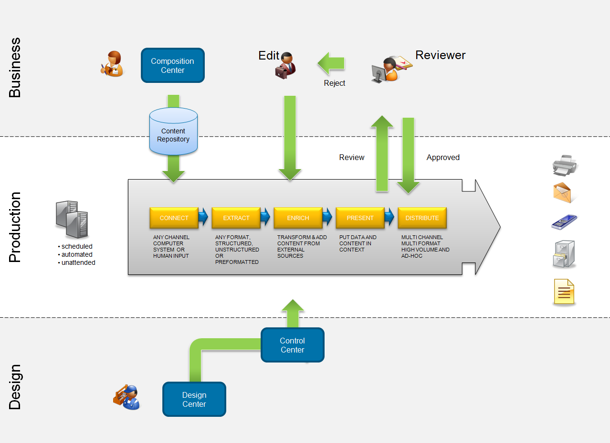
Figure 4: Manual outbound correspondence process

To generate a manual correspondence, users will login to the OpenText screen via Hybris C4C Mashup. User will select the correspondence from a drop down list. Empower Editor will retreive the predefined OpenText template where the content of the correspondence will be pulled to compose the correspondence. Empower Editor will also extract S/4HANA data such as BP #, Contract Account #, Contract # and the BPs preferred communication channel such as email, voice, SMS, TTY or U.S. mail and associated contact information such as email address, phone number and mailing address. If the BP preferred communication channel is email, voice call, SMS or TTY, OpenText will push the data to Nuance using I-CIM-CS-11 - Interface to send Notification from OpenText to Nuance. Other information may include the Contract Account account balance and other information depending on the data elements identified for the correspondence using E-CIM-CS-11 Passing SAP data to Outbound Correspondence Tool. The data elements and content of the correspondence is documented in each correspondence Functional Specification.
After the user has selected the correspondence, the user will be prompted to select information such as:
  - Preferred communication channel to send correspondence. The BPs preferred communication channel is defauled but the user is able to override the default channel. However, this action does not update the BP preferred communication channel that was initially setup in BP preferences.
  - Contact information such as email ID and mobile phone. The user is able to overwrite the contact information. If the BP contact information is marked ‘Do No Use’ due to BP request, an error message will be shown on Empower Editor to alert user to choose a different communication channel.
Before the correspondence is submitted and sent to the BP, the user will perform the following actions in Empower Editor:
  - Preview the correspondence. A mock up screen can be seen in Figure 5.
  - Add, edit or delete a paragraph of the correspondence content. This needs to be predefined and will be documented in the Functional Specification

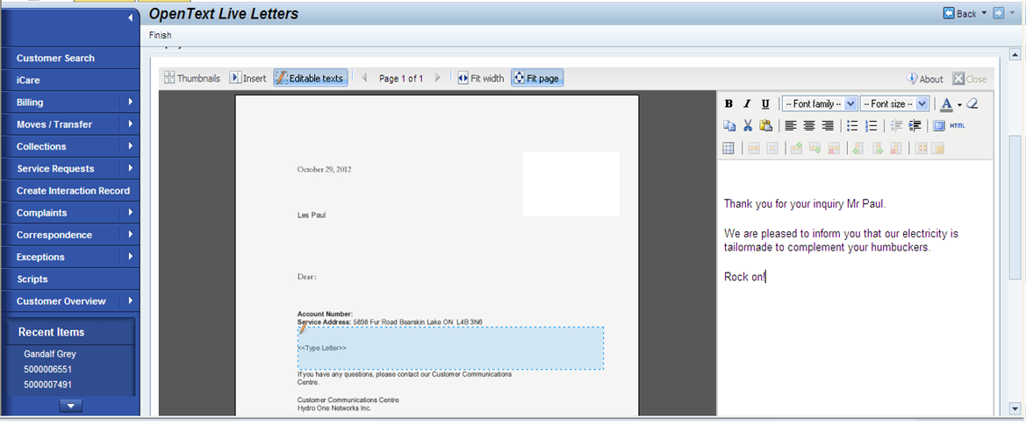
Figure 5: Preview correspondence mock up screen

The user will select submit when the correspondence is ready to be sent to the BP. The communication server of OpenText will send correspondence to the BP.
A BP Contact will be created by OpenText in S/4HANA automatically when correspondence is sent to BP. If the correspondence requires supervisor approval (optional), a notification will be sent to the supervisor’s SCE email. If the correspondence is still pending for approval after 1 day (configurable), an escalation notification email will be sent to the next level of management.
The supervisor is able to edit the correspondence while approving the correspondence. If the supervisor approves the correspondence, the correspondence is sent to the BP. If the supervisor rejects the correspondence, a notification is sent to creator of the notification via email to revise the correspondence.

Automatic Outbound Correspondence
Automatic outbound correspondence is generated by the system automatically. The correspondence can be generated based on the execution of a SAP transaction or a batch job that creates correspondence based on business rules, such as a Dunning Notice. When an outbound correspondence is generated in S/4HANA, the data will be pushed to OpenText (US Mail only) using XML structure file (E-CIM-CS-11 Passing SAP data to Outbound Correspondence Tool). The XML structure contains all information such as Correspondence ID, BP, Contract Account, mailing address, etc. The Functional Specification document will document the triggering process of the correspondence, layout, and the data elements required for the correspondence.
Demand Response Notification generated by PP-CS-04-01 will trigger enhancement CIM-CS-11 - Interface to send Notification from SAP S/4 HANA to Nuance where a file will be sent to a file server and Nuance will process the file and send Notifications to customer. Enhancement E-CIM-CS-11 Checking on Customer Preference will be triggered to obtained the customer preferred communication channel.
Budget Assistance Notification generated by PP-CS-02-13 will trigger enhancement CIM-CS-11 - Interface to send Notification from SAP S/4 HANA to Nuance where a file will be sent to a file server and Nuance will process the file and send Notification to customer. Enhancement E-CIM-CS-11 Checking on Customer Preference will be triggered to obtained the customer preferred communication channel.
Outage Notification generated by DF-WM-02 Handle Field Orders – Manage Field Orders will trigger Workflow W-CIM-CS-04 Communication Rules where the workflow will determine if the Notification can be sent to customer based on business rules. If the Notification is ready to be sent to customer, the Workflow will trigger CIM-CS-11 - Interface to send Notification from SAP S/4 HANA to Nuance where a file will be sent to a file server and Nuance will process the file and send Notification to customer. Enhancement E-CIM-CS-11 Checking on Customer Preference will be triggered to obtained the customer preferred communication channel.
Final Call Notice generated CC-FI-04 will trigger enhancement I-CC-FI-04 - IVR final call and alerts where a file will be sent to a file server and Nuance will process the file and send voice call to customer. Checking on the customer preferred communication channel is not required as the communication channel is always voice call.
A copy of automatic correspondence of type SMS, voice call, email and TTY will not be archived in OpenText xECM. Automatic correspondence of type US Mail will be archived in OpenText xECM. A copy of the BP Contact will be created by Nuance using E-CIM-CS-11 - Auto IR creation for Inbound & Outbound Correspondence/Communication.
The triggering process of the correspondence will create a log file documenting the number of correspondence processed sucessfully and the number of correspondence that failed to process. This will be documented in the respective Functional Specification. The IT User will use S/4HANA (tcode SP01) to view the log file. The IT user will double click on the log file spool number to see the content of the file (Figure 6).
The log file will also document records that failed to process due to BP contact information being marked as ‘Do Not Use’. When automatic outbound correspondence is not generated due to BP contact information being marked as ‘Do Not Use’, the system will create a BP Contact labeled Action ‘Outbound Correspondence’ and Class ‘Failed’. The correspondence name, BP contact information and failed reason such as ‘BP contact information is marked Do Not Use’ will be documented in the BP Contact long text by the respective triggering process that creates the automatic outbound correspondence.
Users can leverage a self-service report to extract the list of failed outbound correspondences that failed to be delivered due to the BP contact information being marked as ‘Do Not Use’ or other reason (e.g., phone busy, email address inactive, etc) to update the BP contact information. These BP Contacts will be available in Hybris C4C BP Contact view.
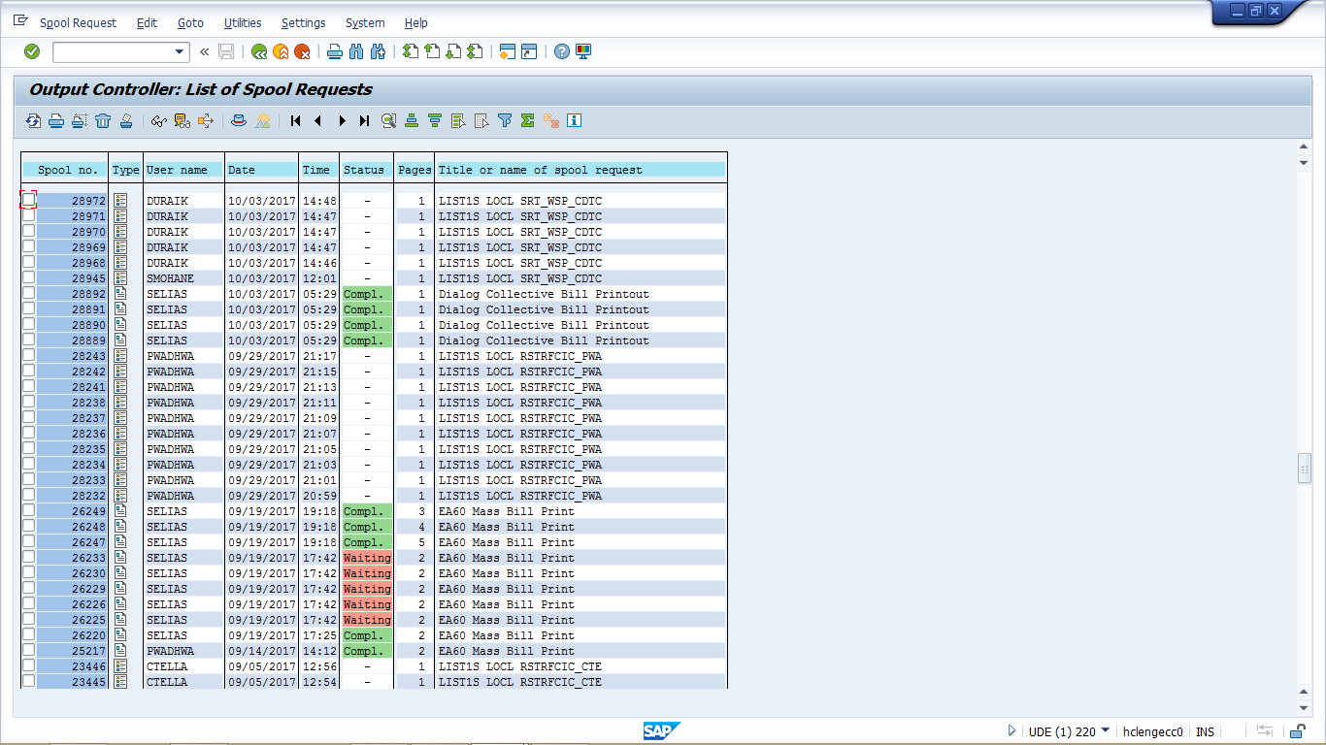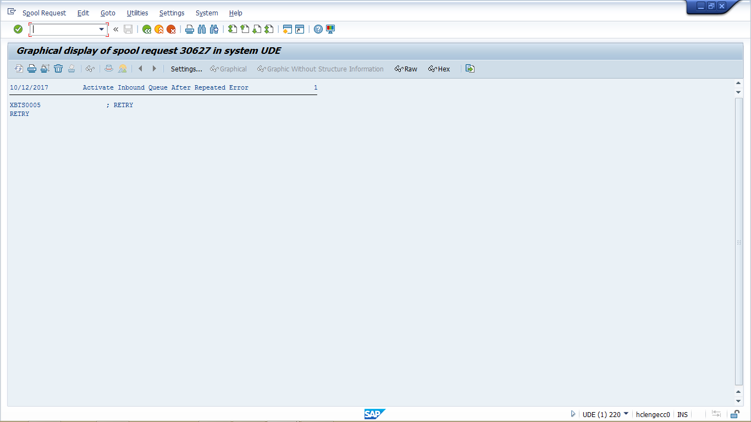
Figure 6: Spool file

Upon receiving the XML file structure, OpenText will retrieve the correct OpenText correspondence template and format the correspondence accordingly. The OpenText Communication Server will then push the correspondence to the BP via BP their preferred communication channel.
If the letter is defined having automatic and manual capability, a user can send the same communication to the BP again if needed. The only way this can happen is when BP requests front office user to manually generate the letter after system has generated the letter automatically. User can also go to xECM to retrieve the correspondence image and resend it to BP.

Manual Mass Outbound Correspondence
Manual Mass Correspondence is correspondence that is generated by a user manually in mass based on business rules. Refer to CIM-CS-15 Manage Customer Segmentation & Campaign Management for more information about this functionality.

Obtain Customer contact information
A common program (function module) will be built using E-CIM-CS-11 Determine correspondence address for the purpose of ensuring that all correspondence will have the same logic to obtain customer contact information. This program will be triggered by all outbound correspondence RICEFW ‘Forms’. This program will obtain the customer valid contact information such as mailing address, mobile phone number, phone number and email address depending on the customer preferred communication channel. Any customer contact that is marked ‘Do Not Use’ due to customer request will not be selected as valid contact information.

Handling of data files
The BPs preferred communication channel will determine how the data files are handled from initiation of the correspondence to when correspondence is sent to the BP.
OpenText Exstream has the ability to display the Signature, Reference Code, and the Version Number in correspondence that requires a signature for the BP preferred communication channel for US mail and email. The Reference Code and Version Number need to be maintained in a custom table that is referenced in section 2.1.7 - Correspondence Master table.
A batch job will be scheduled every 10 mins for non US Mail correspondence and once a day for US Mail correspondence calling E-CIM-CS-11 Creating automatic outbound correspondence. The enhancement will check the preferred communication channel of the correspondence, if the preferred communication channel is ‘SMS’, ‘Email’, ‘Voice Call’ and ‘TTY’, the enhancement will create an XML file and stored in the file server for OpenText to process the file. If the preferred communication channel is ‘US Mail’, the enhancement will create an XML file and stored in the file server at end of the day for OpenText to process the file.
Notification such as Demand Response, Budget Assistant, Outage and Final Call Notice are sent to customer in near real time as these notification is sent to Nuance directly.

US mail
For automatic correpondence, the triggering process will generate spool files in S/4HANA and store them in the S/4HANA spool. A custom program in S/4HANA will be scheduled at the end of the day to collect these files from the spool, create a XML file and upload to file the server using E-CIM-CS-11 Creating automatic outbound correspondence. For manual correspondence, Exstream will create a XML file and upload it to the file server whenever a manual correspondence is submitted by the user using Empower Editor.
At the end of the day, OpenText will consolidate all of the XML files from the file server and generate an AFP (Advance Function Presentation) file that is defined by the GO3 file server. The AFP file will be uploaded to the G03 file server and the G03 file server will process the AFP file to print the correspondence. There will be various pre-printed SCE letterhead types for various correspondence types such as Bill Stock or Inserts, Exstream will name the AFP filename according to the GO3 file server specification. The GO3 file server will retrieve the AFP files based on file name and print the correspondence on the designated paper type for that correspondence.
A log file will be generated to report on the number of correspondence uploaded to the GO3 file server. Refer to next section (Control Report) for more information.

Email, SMS, TTY & Voice call
For automatic correspondence, the triggering process for correspondence will create XML file using I-CIM-CS-11 - Interface to send Notification from SAP S/4 HANA to Nuance and place the XML file to a file server. Nuance will process the files in the file server and send the correspondence to the BP based on the BP preferred communication channel.

For manual correspondence, if the selected communication channel for the correspondence is SMS, voice call, TTY or email, Exstream will send the correspondence in a XML file to the Nuance file server after user has submitted the correspondence. Nuance will process the file in the file server and send the correspondence to the file server.

Control Report
A log file/control report for reconciliation will be generated in S/4HANA with the purpose of providing visibility to the number of correspondence uploaded to OpenText to send to BP.
For manual correspondence and automatic correspondence (US Mail), OpenText will provide a control report. The control report will provide information about the number of correspondence that passes to OpenText and number of correspondence processed and sent to GO3 (print services) file server.
For automatic correspondence (SMS, Voice Call, Email and TTY), a self service report can be used to the extract BP Contact created for outbound correspondence and the channels. This will be the control report for correspondence that sent to Nuance.
Nuance and GO3 file server will have a control report available providing the number of correspondences received and sent to BP for the day.
SCE IT user can use Control Report from S/4HANA, OpenText, Nuance and the GO3 control report to perform reconcilation if required.
System shoud have the ability to re-trigger not processed correspondence in case the server is down when the job is scheduled, however business rules need to be defined (will be covered in W-CIM-CS-04 workflow) to clartify what correspondance should be sent based on the status changes in the system for that particular event that is triggering the notification to the BP. For example, the status of an outage for a BP can change multiple time before the sytsem is back up. This may need to have IT intervention to re-trigger the job.

Correspondence Master Table
A customized table will be created in OpenText to host the correspondence information. This table contains information that is required by OpenText to have the correspondence generated. Some of the information such as Reference Code and Version number will be shown at the bottom of the correspondence.
Information for Manual and Automatic correspondence will be documented in this table by an authorized user in OpenText.

No. | Field Name | Description
1 | Correspondence Id | Internally defined correspondence ID, to be used by OpenText
2 | Correspondence Name | Name of the correspondence for reference purposes
3 | OpenText template ID | OpenText template ID
4 | Layout | Portrait / Landscape
5 | Number of pages | 1, 2, 3, 4 or 5 etc.
6 | Print on front and/or back | Print on the front and/or back of the page
7 | G03 file name convention | File naming convention for G03 print facility (US Mail)
8 | Editable | Correspondence is editable during preview
9 | Reference code | Reference code that shows at the bottom of the correspondence
10 | Version number | Version number of the correspondence that shows at the bottom of the correspondence
11 | Attachment | Attachment or Insert required at GO3 print facility
12 | Language | Language
13 | Action | Action for BP Contact
14 | Class | Class for BP Contact

Handling of Trouble Order and Outage Alerts
Touble Order and Outage Alerts process is a complex process that contains various components. The creation of the Service Order is handled by D&F (DF-WM-02 Handle Field Orders – Manage Field Orders). The business rules around sending alert is in the Workflow W-CIM-CS-04 Communication Rules. When the alert is ready to be sent to the customers, Workflow will pass the list of BP numbers to E-CIM-CS-11 - Passing SAP data to Outbound Correspondence Tool. E-CIM-CS-11 Checking on Customer Preference will check Customer Preference if that correspondence category requires notification to the Account Manager or another other recipients.
If the BP of record or authorized BP is enrolled in Outage Alerts for the account, they will automatically receive outage alert updates for those accounts via the channel they perfer. Trouble can be reported via sce.com, IVR and by calling SCE. If the BP of record or authorized BP reports the trouble (outage and non outage), they can provide their phone or email address to receive a trouble order confirmation notification via email, voice , TTY or SMS. If someone reports trouble (outage and non-outage) and they are not the BP of record or an authorized BP for the account, they can also provide a phone or email address (Figure 7) to receive a trouble order confirmation notification and update notification via email, voice, TTY or SMS. In both cases, they can use the service order number provided to check the status of the trouble they reported on sce.com, via IVR, or by calling and talking with an Energy Advisor.

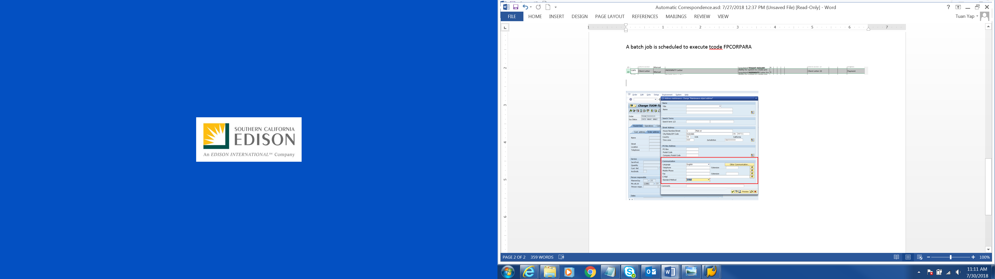
Figure 7: Service Order

A BP Contact will be created when the notification is sent to a BP if an outbound notification is sent to BP. BP Contact will not be created for a non-BP. BP Contact will contain this information:
- BP Number
- Class – ‘Outbound Correspondence’
- Action – Any of the type of outage notification such as below:
  - Emergency Maintenance Outage Power Restoration Alert
  - Repair Outage Restoration Alert
  - Maintenance Outage Restoration Alert
  - Streetlight Outage Trouble Order
- Type – ‘Email’ or ‘SMS’ or ‘Phone’ or ‘TTY’
- In/Outgoing – ‘Outgoing’
- Date/Time – System date and time
- Long Text – Information about the outage and information is passed from the workflow, as well as, the phone or email used to send the communication

E-CIM-CS-11 Checking on Customer Preference will be triggered by I-CIM-CS-11 - Interface to send Notification from SAP S/4 HANA to Nuance to obtain customer preference information along with and the designated contact person that setup in customer preference to receive notification along with the BP that lives in the affected outage area.
The following notification/alert type will be sent to the BP based on the Service Order status. D&F program will pass the status to workflow for W-CIM-CS-04 Communication Rules which then passes the status to E-CIM-CS-11 - Passing SAP data to Outbound Correspondence Tool in order to identify the notification type to be sent to BP.
Service Order Status | Notification/Alert type
Repair Outage (unplanned)
Create | Repair Outage Alert
Any status that is not Create and Completed | Repair Outage Update Alert
Cancel | N/A
Completed | Repair Outage Restoration Alert
Maintenance (planned)
Create | Maintenance Outage Alert
Any status that is not in Create and Completed | Maintenance Outage Update Alert
Cancel | Maintenance Outage Cancellation Alert
Rescheduled | Maintenance Pending Reschedule Alert
Completed | Maintenance Outage Power Restoration Alert
Streetlight Trouble Order
Create Confirmation | Streetlight Trouble Order Alert

BP Contact
A BP Contact will be created on a BP each time a Trouble or Outage Alert is sent to the BP using E-CIM-CS-11 - Auto IR creation for Inbound & Outbound Correspondence/Communication documenting the date, time and information about the update that provided by workflow W-CIM-CS-04 Communication Rules.
Any reply from BP to the Notification via email, voice call, TTY or SMS such as delivery status and opt-out request will get updated to the same outbound notification BP Contact. Refer to CIM-CS-09 Handle Inbound Request for more information.
User can use a self-service reports to extract the BP Contact records for list of alerts sent to BPs based on customer preferred communication channel. To view alerts sent to contact information in the Trouble order, the user will need to run a self-service report.

Notification Black Out window
Workflow W-CIM-CS-04 will check for black out window maintained in Customer Preferece for the BP (refer to BPD CIM-CS-01 – Business Master Data - Manage Business Partner for black out window identifier). By having this check, the BP will not receiveany Notification within black out window for preferred communication channel ‘Voice call’ only. Assumption is that user is not allowed to maintain Black out window for preferred communication channel other than ‘Voice call’.
Customer preferred communication channel will also be identified using E-CIM-CS-11 Checking on Customer Preference.
BP Contact will not be created or updated as there is no notification is sent to the BP. If the BP calls to ask about not receiving the notification, user will need to look at the customer preference on the black out window.

Dunning Alerts and Final Call Notifications
When a BP enters the dunning process and is at risk of disconnect, as well as, when they reach final call status, a file will be generated by CC-FI-04 - Manage Collections (Dunning) - Manage Credit and Collections. The file will contain BPs and accounts which meet the condition so that the system can send the BP a digital alert (email, voice, SMS, or TTY) and U.S. mailed letter (based on business rules) to the BP. CC-FI-04 - Manage Collections (Dunning) - Manage Credit and Collections will pass the list of customers to ehancement E-CIM-CS-11 - Passing SAP data to Outbound Correspondence Tool where Notification will be sent to customers via customer preferred commnication channel. The list of final call notifications for Residential and Non Residential are:
  - Reminder
  - Final Call
  - Before Cut

Demand Response Events
Notification is sent to customer depending on Demand Response Events. Refer to BPD PP-CS-04-01 Manage Support Program Operations - Demand Response Management for more information on the triggering events.The list of customers to receive the Demand Response Notification will be provided by the enhancement from PP-CS-04-1 “Enhancement to facilitate the maintenance of TLM data in SAP S/4 HANA”. Internal users who have subscribed to receive the notification will also be included in the file.
PP-CS-04-01 enhancement will pass the list of recipients to enhancement E-CIM-CS-11 - Passing SAP data to Outbound Correspondence Tool where customer preferred communication channel will be obtained and Notification will be sent to customers via customer preferred communication channel. This enhancement will then create a file and place the file in the file folder for Nuance or OpenText to process.

Budget Assistant
Notification is sent to customer depending Budget Assistant alert condition. The list of Budget Assistant Notifications are:
  - Under non TOU
  - Under TOU
  - Above non TOU
  - Above TOU
  - Bill is ready
  - Demand GS1
  - Demand GS2
For more information around Budget Assistant Notifications and triggers, please refer to BPD PP-CS-02-13 Budget Assistance.
Enhancement from PP-CS-02-13 “Interface to send Budget Assistant Alert notifications to Nuance”will send the list of Budget Assistance Notification to Nuance by triggering enhancement E-CIM-CS-11 - Passing SAP data to Outbound Correspondence Tool. This enhancement will obtain the customer preferred communication channel in Customer Preference using E-CIM-CS-11 Checking on Customer Preference. This enhancement will then create a file and place the file in the file folder for Nuance or OpenText to processed. A BP Contact will be created using E-CIM-CS-11 - Auto IR creation for Inbound & Outbound Correspondence/Communication.

2.2 Process / Performance Improvement
- One central repository system for managing outbound correspondences
- Able to preview and edit the correspondence in the system before sending to BP
- Verification that Phone, Mobile phone, Email & mailing address is valid and retrieved from one single source – SAP
- Ability to view correspondence sent to BP in a central repository

2.3 Prerequisites and Inputs
- BP and/or Contract Account, Contract, or premise information must be located in Hybris C4C when composing correspondence
- Email ID is prerequisite for sending correspondence & communication via email
- SMS Text enabled phone number is prerequisite for sending alert/message via text
- Phone number or Mobile phone number is pre-requisite for making voice call to BP
- Mailing address is pre-requisite for sending US mail
- Connection is established between OpenText Exstream and Nuance for outbound email, SMS and voice call
- Connection is established between OpenText Exstream and Printing facility at GO3 for outbound US mail
- Connection is established between OpenText Exstream and OpenText xECM for storing of outbound correspondence image

2.4 General Assumptions
- OpenText Exstream is able to send correspondence to BP via various channels such as email, SMS, voice call, TTY and US mail
- OpenText Exstream will have these features available when user is composing ad hoc correspondence:
  - Content of the correspondence is editable
  - Predefined sentences are available for user via drag and drop feature
  - Preview of the correspondence prior sending to BP
  - SCE privacy notice and opt out will be applied to all outbound correspondence as appropriate
- Whenever an outbound correspondence is generated by OpenText Exstream, a copy of the outbound correspondence image will be stored in OpenText document repository system (xECM) for US Mail and Email only.
- 3rd party notification system (Nuance) will be used to send outbound SMS, Email, TTY and make outbound voice call
- 3rd party notification system (Nuance) and GO3 file server are able to provide Control Report with information such as number of correspondence received and number of correspondence sent to BP for a particular day
- When the ‘creator’ sends correspondence for approval to Supervisor or Manager, the correspondence must be ready to present to the BP.
- The only reason the ‘creator’ would receive the document back from the supervisor is if the communication does not meet supervisor/manager approval. The creator will update the communication and re-submit for approval.
- Documents will follow the retention schedule defined by SCE ACT policy. Retention schedule will not be defined as part of this BPD.
- Marketing & Campaign correspondence is out of scope for this BPD.
- All correspondences sent out using OpenText will not contain customer PII information.
- Nuance will have the capacity to meet SCE’s growing threshold for outbound correspondence.
- The content/requirements/rules that are related to Trouble and Outage notifications have been moved from Outbound communications and submitted to D&F and CIM-CS-04. The assumption is that these will be handled and accepted by D & F and CIM.

2.5 Business Process Hierarchy
This Business Process Hierarchy provides a listing of all scenarios/business processes, sub-processes, and SAP Transaction codes identified to support this process.
Level 1 | Level 2 | Level 3 | Level 4
Front Office | Manage Outbound Request | Manual Correspondance creation | Hybris C4C Mashup (OpenText)
Back Office | Manage Outbound Request | Automatic Correspondance creation | S/4HANA respective process tcode
Back Office | Mange Outbound Request | View log file in S/4HANA spool | SP01

2.6 Process Flows
This BPD will cover Outbound Correspondence processes, including Manual Outbound correspondence, Automatic Outbound correspondence. Each subsection where the process is detailed will have a process flow diagram for that process and a table detailing the steps that are taken within that process including processes handled outside of SAP.

2.6.1 Manual Outbound Correspondence
This process describes the process of handling manual outbound correspondence.

Process Flow Diagram

Process Flow Steps

Step | Description of Step | C4C/ T-Code | Role(s) | If step is relevant for a Control, add Requirement  ID
10 | Start
30 | Select correspondence.  Select the correspondence to be generated. | C4C Mashup (Empower Editor) | Manual Outbound Correspondence
40 | Select communication channel  Communication channel is defaulted. User is able to overwrite communication channel. | C4C Mashup (Empower Editor) | Manual Outbound Correspondence
50 | Preview correspondence  Preview the correspondence | C4C Mashup (Empower Editor) | Manual Outbound Correspondence
60 | Edit allowed?  If edit allowed, go to step 70. Otherwise, go to step 80. | C4C Mashup (Empower Editor) | Manual Outbound Correspondence
70 | Edit correspondence  Edit the correspondence. | C4C Mashup (Empower Editor) | Manual Outbound Correspondence
80 | Submitted?  If correspondence is submitted, go to step 110. Otherwise, go to step 40. | N/A | N/A
110 | Channel is email/SMS/Voice call?  If communication channel is email or SMS or voice call, go to step 140. Otherwise, go to 120. | N/A | N/A
120 | Channel is US mail?  If communication channel is US mail, go to step 150. Otherwise, go to step 130. | N/A | N/A
130 | Channel is send to printer?  If communication channel is send to printer, go to step 160. Otherwise, go to step 140. | N/A | N/A
140 | Nuance to process data file  3rd party notification system (Nuance) picks up correspondence data file and process the file. Go to step 170. | N/A | N/A
150 | GO3 process data file  GO3 picks up correspondence data file and process the file. Go to step 170. | N/A | N/A
160 | Print correspondence  Correspondence is printed. | N/A | N/A
170 | Send correspondence to BP  Correspondence is sent to the BP. | N/A | N/A | CONTROL-CS-2354
180 | Create BP Contact  A BP Contact is created. | BCT0 | Manual Outbound Correspondence
190 | Upload correspondence to OpenText xECM  An image copy of the correspondence is stored in xECM. | OpenText | N/A
200 | End

2.6.1 Automatic Correspondence
This process describes the process of handling automatic correspondence.

Process Flow Diagram

Step | Description of Step | C4C/ T-Code | Role(s) | If step is relevant for a Control, add Requirement  ID
10 | Start
20 | Automatic correspondence?  If it is automatic correspondence, go to step 70. Otherwise, go to step 170. | N/A | N/A
70 | Processes generate correspondence  Respective processes generate correspondences upon completion. | S/4HANA | Automatic Correspondence
80 | Generate log file  Program generates log file and stores in the spool. | S/4HANA | Automatic Correspondence
90 | Channel is email/SMS/Voice call/TTY?  If communication channel is email or SMS or voice call, go to step 100. Otherwise, go to 160. | N/A | N/A
100 | Nuance to process data file  3rd party notification system (Nuance) picks up correspondence data file and process the file. Go to step 130. | N/A | N/A
110 | Channel is US mail?  If communication channel is US mail, go to step 120. Otherwise, go to step 170. | N/A | N/A
120 | GO3 process data file via OpenText  GO3 picks up correspondence data file from OpenText and process the file. | N/A | N/A
130 | Create BP Contact  A BP Contact is created. | BCT0 | Automatic & Manual Mass Correspondence
140 | Send correspondence to BP  Correspondence is sent to the BP via BP preferred channel. | N/A | N/A | CONTROL-CS-2354
150 | Correspondence is US Mail?  If Correspondence is US Mail, go to step 160. Otherwise, go to step 170. | S/4HANA | Automatic Correspondence
160 | Upload correspondence to OpenText xECM  An image copy of the correspondence is stored in xECM. | OpenText | Automatic Correspondence
170 | End

2.7 3rd Party and SCE Legacy System Integrations
Identify 3rd Party and SCE Legacy systems that are integrated to this Process and provide a description of the integration and required change together with an estimate of the complexity of the change. This section should relate closely to the Interfaces captured in the Technical Considerations section of this BPD.

3rd Party or SCE Legacy System Integration | Description of Integration and Required Change to 3rd Party or SCE Legacy System | Estimated Complexity of 3rd Party or SCE Legacy system change
OpenText Empower editor Integrate with S/4HANA | SAP passes data to OpenText | Medium
3rd party notification system integrate with OpenText | Sending outbound correspondence in SMS, email and voice call | Complex
OpenText integrate with S/4HANA | Creating BP Contact | Medium

2.8 Data Elements
N/A

2.8.1 Outbound Correspondence
The following data elements will be used by the outbound correspondence.
Field | Type | Comments
Business Partner | Optional | This is the BP number of the BP.
Contract Account | Optional | This is the CA of the BP.
Contract | Optional | This is the service Contract of the BP
Premise | Optional | This is the Premise of the BP.

2.8.2 Source Systems and Data Volumes
The following statistics are the client letters generated for the past 3 years:
Year | Volume
2015 | 841,493
2016 | 1,056,405
2017 | 909,227

2.9 Cloud for Customer (C4C) Integration

2.9.1 Processes
- User is able to generate manual correspondence to send to BP
- System is able to generate correspondence automatically and send to BP
- User is able to generate list of correspondences based on an upload file

2.9.2 C4C Views
A Hybris C4C Mashup view (Empower Editor) that allows user to compose and send correspondence to BP

2.9.3 Activity / BP Contact
BP Contact is created automatically when an outbound correspondence is uploaded to xECM

2.10 Exception Management Requirements
User Exception Scenario / Description | User Group | Initiated by | Work Distribution
N/A

2.11 Process Risks and Mitigation
Risk Statement | Mitigation
If communication fails the BP will not be sent the intended communication. | Report for when a communication fails so the communication can be sent via an alternative method as needed.

2.12 Key Performance Indicators
The following have been identified as KPI’s at Southern California Edison, along with the means of measuring each KPI and the current measurement statistic for each KPI:
Measured KPI | Description | Measurement Method | Current Statistic
N/A

2.12.1 Key Metric Definition
The following have been identified as key metrics at Southern California Edison that require business rule for calculation:
Key Metric | Description | Business Rule | Reference
N/A

3 Controls, Regulatory Rules, and Security
Requirement  ID (from RTM) | “As-Is” Control Requirement | “To Be” Risk Statement | “To-Be” Control Activity” | Control Automation (manual, IT dependent- manual, automated | Relevant technical identifier or RICEFW reference
CONTROL-CS-1216 (Out of Scope) | Provide Training to Employees that Develop Content for Customer Notices (DisabRA Settlement Agreement): SCE is required to provide training, as needed, to employees that develop/design content for written customer notices on importance of providing access to individuals with disabilities. (See DisabRA Settlement Agreement, IV.E.2). | Noncompliance or misinterpretation with regulatory and legislative requirements may lead to misstatement of financial statements, penalties, fines and/or prosecution from governing regulatory bodies | Out of scope because this process does not provide editing the content to cater to the individuals with disabilties. The process to make edits by Consumer Affairs or CCC are outside this process. | N/A | N/A
CONTROL-CS-2354 (Covered by CIM-CS-11-R0001) | SCE is required to notify affected customers of a planned outage at least 3 calendar days before an outage event. SCE may notify customers by US mail, by phone, in-person or door-to-door through door hangers, or by e-mail if SCE has the customer’s e-mail address on file. If a planned outage is rescheduled to a new date not specified in the original notice to the customer, SCE will provide a new notice at least three calendar days before the rescheduled planned outage. (Service Guarantee Standard 3; See also SCE’s tariff in Section E.4 of the Preliminary Statement). | Noncompliance or misinterpretation with regulatory and legislative requirements may lead to misstatement of financial statements, penalties, fines and/or prosecution from governing regulatory bodies | SCE provides notifications by US Mail, by phone, or by e-mail if SCE has the customer’s e-mail addresss on file for outage notifications. (Outage Requirement met in Outage BPD and in-person or door-to-door through door hangers are cover in DF-WM BPDs))  N-DF-WM-02-102 (Outage notice to customer within 3 days). N-DF-WM-02-076 (Outage notification by door hangers) | Manual for Manual Correspondences & Automated for Mass/Automated Correspondences | N/A
CONTROL-CS-2358 (Out of Scope) | SCE shall follow-up with customers who complain about their bills, customers who are behind on their bills, and customers who have been contacted about disconnection or have been placed on a payment plan. SCE is directed to follow-up with each customer through the customers' preferred method of communication (phone, email or mailer) on potential EMT solutions to reduce those customers' bills and avoid disconnection. At a minimum the follow-up would include:  a. Direct installation energy management technology measures available through energy efficiency, demand response (including direct install measures that provides a rebate, like Air Conditioning Cycling), and low income or Middle Income Direct Install programs that may be available to the customer;  b. Specific rebates for energy management technology products and programs that may be available to the customer that would be tailored to meet the customer’s climate zone, energy consumption patterns, and the home vintage of the customer;  c. Directions on how to access the updated energy technology marketplace website and understand the relevant product information that would be obtained there (product pricing, product rebates available, savings estimates for the products, customer reviews etc.); and  d. Directions to and tips for navigating the IOU online tools to monitor energy usage and perform online audits, such as through MyAccount, and instructions on how to sign up for bill alerts or bill forecasts. | Noncompliance or misinterpretation with regulatory and legislative requirements may lead to misstatement of financial statements, penalties, fines and/or prosecution from governing regulatory bodies | Out of Scope: This BPD covers methods for outbound communications and there is a Complaints BPD covering complaints,  a. BP Communications Preferences BPD, covering preferred methods of communications (Manage BP),  b. Information on energy management technology mesures are available on SCE.com,  c. iEnergy covers the Rebate Programs scope,  d. directions & tips for SCE online tools to monitor energy usage are covered in SCE.com.

3.1 Security Considerations
Guidelines:
- Identify task functions for the processes and sub processes in the Role column. This will be used to establish SAP Technical Roles in SAP by Security during build phase security workshops conducted with process teams
- In the Functional Restriction column, identify any sensitive/critical t-codes or confidential and elevated access t-codes
- Identify any known cross- functional business processes that will have potential SOD (Segregation of Duties) conflicts and ensure any applicable mitigating controls are identified in the above Section 3
- Special Considerations should be noted if there is any of the following:
- Segregation of Duties (SOD) - Control that is based on the system authorization concept to assist in segregating system and non-system duties that could cause conflicts of interest
- Sensitive Access – System based control that is based on the system authorization concept
- Elevated Access - Privileges temporarily assigned and highly monitored to address emergency situations. Includes sensitive and confidential access. Access managed in Firefighter. Requires additional review of activity logs to confirm access was appropriately used for the emergency need.

Role | Transaction Code (T-Code) | T-Code Description | Functional Restriction | Organizational Restriction
Manual Outbound Correspondence | Hybris C4C Mashup (OpenText Empower Editor) | OpenText screen to generate correspondence | Create/Change/Delete | N/A
Automatic Correspondence | S/4HANA | Create automatic correspondence | Create | N/A
Automatic & Mass Outbound Correspondence | SP01 | Access to the spool to locate the log file created by Automatic and Mass Outbound Correspondence process | View | N/A

3.2 Custom Program/Transaction Codes
Custom Program | Authorization Grp | Custom T-code | Authorization Object used in the authorization check statement

3.3 Custom Table/Transaction Codes

Custom Table | Authorization Grp Assigned | Custom T-code for the Table | Table Access (display/update) | RICEFW Reference ID

3.4 Data Criticality and Cybersecurity Baseline Risks
Specify Data Classification /Special Handling or Regulatory Requirement  What is the classification of Data? Does it trigger any special regulations?  Please select the classification / Sensitivity of the Data. This will help us Assess the Risk associated and remediation measures if any. | <Select all that apply>  ☒ PII - Personal Identifiable Information / Privacy Law  ☐ CEII - Critical Energy Infrastructure Information  ☐ FERC SOC (Standards of Conduct)  ☐ NERC CIP Confidential  ☐ Sarbanes-Oxley (SOX) financial reporting data  ☐ SCE utility data accessible by affiliate companies (CPUC)  ☐ PCI - Payment Card Industry Compliance  ☒ Customer Information Service Request (CISR, CISR-DRP)  ☐ Other _<Please Specify>_  ☒ Internal  ☒ Public  ☒ Confidential
Please identify which business Group/Role will require access to the data and/or solution:  Please select the list of Busines Groups will have access to this Data / Process. This will help us Determine the Impact and Risk Spread. Will ensure efficient Risk mitigation measures. | <Select all that apply>  ☐ SCE Customer, Res./Comm. Customer;  ☒ SCE OU, Business Function Organization Name: CCC, BCD, RSO, CP&S, T&D  ☐ Vendor  ☐ External business partner(s) & SaaS providers  ☐ External on-shore contractors  ☐ External off-shore contractors  ☐ SCE Affiliate Company Employees  ☐ SCE Employees, specify if they have Marketing Function responsibilities (e.g., ES&M)  ☒ SCE contract workers  ☐ Regulatory Agencies  ☐ Others _<Please Specify>_
How many of the SCE Customer, Employee, Vendors will use or affected by the Business Process?  To identify the Impact if services are adversely affected. | 100 - 1,000
How much Information/data would be processed, received or tramitted by the Business Process?  The data volume that will be utilized by this process. Helps us in determining the Impact and criticality | 100 MB / GB  100 - 1,000 MB / GB  1,000 - 10,000 MB / GB  10,000+ MB / GB…..
Number of business transactions in average?  These are the number of transactions process by the application on average. The number of transactions help in understanding criticality and Impact. | Millions
Additional Security Consideration: | Any Cybersecurity impact in addition to SAP system security:  - Internet Facing Web Application? Yes/No, Details:  - Internet Facing Application Programming Interface?  - 3rd party Fedrated Authentication & Authorization, Single Sign On?

Technical Considerations

4.1 RICEF-W Assessment
All of the Forms, Reports, Interfaces, Conversion items, Extensions/Enhancements and Workflows (RICEF-W) that have been identified for this BPD are detailed in the tables below and will represent the totality of all RICEF-W items documented at the time of sign-off of this BPD. Any RICEF-W items that are confirmed via change control after this BPD receives final sign-off, will be managed within Southern California Edison’s APSE environment and not within this document.

Reports
Report Name & Description (List Requirements met by this Report) | Complexity | Reference ID
A report to provide list of correspondence that saved as draft | Medium | R-CIM-CS-11-03 List of correspondence saved as draft
A report to track the various outbound correspondence based on quantity and creator (eg agent/IVR/SCE.COM etc) | Medium | R-CIM-CS-11-6 Outbound correspondence based on quantity and creator
Ability for the user to report on Active and historical outbound correspondence communication | Medium | R-CIM-CS-11-9 List of communications based on Campaign status

Interfaces
Interface Name & Description (List Requirements met by this Interface) | Complexity | Reference ID
Client Letter interface | Medium | I-CIM-CS-11- Client Letter Interface
Interface to Varoli | Medium | I-CIM-CS-11- CR&B to Varoli
Event Tracking/Participation-Universal (DR Programs)-USER-Ability to receive contract/service account participation dispatch details (create, modify, delete) in real time using an API.  Event Tracking/Participation-Universal (DR Programs)-USER-Ability to receive dispatch information (create, modify, delete) in real time using an API | Medium | I-CIM-CS-11 Interface to send Notification from SAP S/4 HANA to Nuance  ** New Tier1 RICEFW
Automatic correspondence for email, sms, voice call and TTY will be sent directly from S/4HANA to Nuance. | Medium | I-CIM-CS-11 - Interface to send Notification from OpenText to Nuance  ** New Tier1 RICEFW

Conversion
Conversion Name & Description (List Requirements met by this Conversion) | Complexity | Reference ID
N/A

Extension/Enhancements
Extension Name & Description (List Requirements met by this Extension) | Complexity | Reference ID
Ability to show all correspondence (inbound and outbound) as an Activity / BP Contact. Communication channels example include: IVR, live agent, email, notification (e.g. demand response or outage ), marketing info, outage info, late payment notices, face to face interaction  The system shall enable a user to easily view a copy of all outbound communications sent to a BP, user, date/time sent, type of communication, method (email, SMS, voice, U.S. mail) and contact device used | Medium | E-CIM-CS-11 Auto IR creation for Inbound & Outbound Correspondence/Communication  ** Update this RICEFW to Tier 1
To merge the XML files into one XML file and send to OpenText for processing | Medium | E-CIM-CS-11 Creating automatic outbound correspondence
Ability for user to overwrite (one time change) system defaulted email address when user composing a manual correspondence  Ability for user to overwrite (one time change) system defaulted mailing address when user is composing a manual correspondence  Ability for user to overwrite (one time change) system defaulted mobile number when user is composing a manual correspondence  Note: These are standard OpenText features. No enhancement is needed. | Medium | E-CIM-CS-11 Overwrite correspondence contact information
Ability for system to default BP primary email address when user has selected email as the communication channel for the manual correspondence.  Ability for system to default BP primary mobile number when user has selected SMS as the communication channel for the manual correspondence.  Ability for system to default BP standard mailing address when user has selected US Mail as the communication channel for the manual correspondence.  Ability to add new outbound correspondence (proactive & triggered notification) that is configurable by the authorized user  Ability for system to capture a reference code in the outbound correspondence | Medium | E-CIM-CS-11 Passing SAP data to Outbound Correspondence Tool
Ability to flag a physical service address (premise address) as unable to accept US mail | Medium | E-CIM-CS-11-4 Flag service address as invalid
Ability for system to use the Standard mailing address if the Contract Account or Premise address is flagged as unable to accept US mail or needs special handling  System to obtain the customer valid contact information such as mailing address, mobile number, email id based on customer preferred communication channel. This will be a common program that all Forms RICEFW will be using. | Medium | E-CIM-CS-11 Determine correspondence address
The system shall automatically send communication to the customer, when an event is triggered for CARE/FERA | Medium | E-CIM-CS-11-7 CARE/FERA event to send outbound communication
The system shall enable a user to easily view a copy of all outbound communications sent to a BP, user, date/time sent, type of communication, method (email, SMS, voice, U.S. mail) and contact device used | Medium | E-CIM-CS-11 Auto creation of IR for Outbound correspondence  ** This Tier 2 RICEFW to change to Tier 1
Ability for system to generate a reference code for outbound correspondence printed by 3rd party vendor | Medium | E-CIM-PP-11-1 Auto generate reference code
A program to check for black out window and customer preferred communication channel that updated in Customer Reference  The system shall be configurable to send outage information to multiple internal recipients such as districts, BCD and others (similar to CCC process today). | Medium | E-CIM-CS-11 Checking on Customer Preference  ** New Tier 1 RICEFW # 2052

Forms
Form Name & Description (List Requirements met by this Form) | Complexity | Reference ID
N/A

Workflows
Workflow Name & Description (List Requirements met by this Workflow) | Complexity | Reference ID
N/A

IDEX Considerations
N/A

Production System Cut-over Considerations
Legacy Bill Statements that are stored in OpenText will under go conversion. The metadata for legacy Bill Statement image is Contract number (Service Account). Metadata for legacy Bill Statement image will be mapped to new SAP Contract number. This will be done using enhancement C-UB-BI-09 - Bill image PDF migrated to OpenText.

4.6 Other Considerations
N/A

Change Management

5.1 Change Impacts

Change Element Short Description |  | Change Impact Category | Audience Group(s) | Impact | Business Effort
 | Currently, generating and mailing out customer letters is a manual process.  In SAP, the outbound correspondence process will be automated.  Operational Impact: Benefit...Reduction in the manual work effort required to create and send out the appropriate letters  Customer Impact: N/A | Benefit/Improvement;Process;Technology (483) | CS-CSOD-CCC All;CS-BCD-All;CS-CP&S-All;CS-CSOD-RSO All | Medium | Medium
 | In SAP, users will be able to send letter of credit/residency via the customers' preferred communication channel (e.g. email). Currently front office user can only send letters of credit and residency through US Postal mail. SAP provides more flexibility based on the customer's request and allows them to receive it faster than postal mail. | Process;Job Roles;Benefit/Improvement (273) | CS-CSOD-CCC All;CS-CSOD-Consumer Affairs | Low | Low
 | SAP allows for front office users the ability to send the non-cash security and guarantor letters via OpenText. Currently an email is sent to RSO Credit to generate and mail out these letters. There will be no hand off needed to send out the letter. | Job Roles;Process;Benefit/Improvement;Staffing Levels (274) | CS-CSOD-CCC All;CS-CSOD-RSO-Credit;CS-BCD-All;CS-CSOD-Consumer Affairs | Low | Low
 | CCC users will have the ability send the CARE cover letter to the customer for recertification. Currently users send a request for recertification to PSO to process the letter. The change will reduce handoffs and create efficiencies resulting in first call resolution. | Benefit/Improvement;Process (370) | CS-CSOD-CCC All;CS-CSOD-Consumer Affairs | Low | Low
 | Customer Contact Center (CCC) As a process efficiency, the CCC will have the ability to send out the CVD letter regarding the deceased customer. Today, the CCC sends an email to RSO CVD once they receive a call regarding a deceased customer. RSO mails the customer a letter of confirmation. The new process would not require the hand off to RSO to complete the request. | Benefit/Improvement;Job Roles;Process;Staffing Levels (487) | CS-CSOD-CCC All;CS-CSOD-RSO-Credit;CS-CSOD-Consumer Affairs | Low | Low
Front office users will have to navigate through multiple screens to view if a an automatic digital communication was sent to a (BP Contact records and service orders if it was related to an outage or trouble). |  | Process Change (490) | CS-BCD-All;CS-CP&S-All;CS-CSOD-All | High | High
 | In the new system the back office will enter undeliverable mail flag. Front office users can use FOP to view connection object indicator that mail is undeliverable and then in FO update mailing address based on BP call. | Process;Decision Making (959) | CS-CSOD-CCC All;CS-BCD-All;CS-CSOD-RSO All | Low | Low
 | Currently, front office users use specific Outlook mailbox address to send generic mail. In the future, front office users will send information to a Business Partner using a pre-defined template on a topic that will have a generic sender name/email. This is a benefit. | Process;Decision Making;Benefit/Improvement (960) | CS-CSOD-CCC All;CS-BCD-All;CS-CSOD-RSO All | Low | Low
 | SAP correspondence management will be able to manage the manual, automatic and mass manual outbound correspondence. An outbound correspondence can be created manually by a user (single or mass) or automatically by the system. | Benefit/Improvement;Process;Technology (1050) | CS-BCD-All;CS-CSOD-CCC All;CS-CSOD-Consumer Affairs;CS-CSOD-RSO All | Medium | Medium
 | The system will allow emails and phone numbers to be deleted manually by the user and automatically by the system and log the reason for the deletion (eg bad device, blocked etc) due to failures to all impacted BP's. This functionality is currently not available in the current system. Users can manually remove them based on the customer request but there is no log or automated deletion of phone numbers and emails.  Operational Impact: This process will allow users can discuss with customers appropriate changes to their contact information and provide the information to the customer if they call. | Improvement;Decision Making;Process (1090) | CS-BCD-All;CS-CSOD-CCC All;CS-CSOD-Consumer Affairs;CS-CSOD-RSO All | Medium | Medium
 | The system will have the ability to store customer responses to SMS, email, TTY or voice responses. It will include date and time stamp of response as well as the content of the response. This is new functionality and there is nothing comparable today. Front office users will have visibility to any customer responses so that they can respond to any customer inquiries regarding the communication and know what the customer may have responded to. | Improvement;Process;Decision Making;Technology (1091) | CS-BCD-All;CS-CSOD-CCC All;CS-CSOD-Consumer Affairs;CS-CSOD-RSO All | Medium | Medium
 | Manual outbound correspondence and U.S. mailed correspondence will be available to front and back office users. Front office users will access Open Text through a Mashup transaction launcher. Manual correspondence is generated upon BP request or after a user executes a transaction. Examples include Paid in Full letter, Guarantor declined etc. Currently most users generate letter through client letter functionality. | Process;Technology (1081) | CS-BCD-All;CS-CSOD-CCC All;CS-CSOD-RSO All;CS-CSOD-Consumer Affairs | Medium | Medium
 | Within Open Text, after the user selects the correspondence to send to the customer, the user will need to select the communication channel. The user can select the preferred communication channel but also has the option to override the default channel for a one time update. The override option will not update the BP preferred communication channel. This is a one time selection based on the customers' needs. Currently users do not have many options for different correspondence types. Most communications are sent via letters or voice options. There are certain programs that have options to SMS as well but is not available to all correspondence.  Operational impact: It is an added step to determine what communication channel the customer is requesting increasing processing/handle times. If the BP contact information is marked "Do Not Use", an error message will be shown so that the user can discuss with the customer and select a different address/email/phone.  Customer impact; Customer has multiple choices that can lead to customer satisfaction | Improvement;Culture Shift;Process;Technology (1084) | CS-BCD-All;CS-CSOD-CCC All;CS-CSOD-Consumer Affairs;CS-CSOD-RSO All | High | Medium
There will be an increase in handle time in outage. A BP Contact will house the Service Order #. User will use the Service Order # to search for specific Outage information such as Estimate Restoration Time and Premise associated to the Outage. |  | Process | CS-BCD-All;CS-CSOD-CCC All;CS-CSOD-Consumer Affairs; | Medium | Medium

Below is a description of each:
Change Element Short Description: Describes the ‘As-Is’ scenario and what is changing.
Change Impact Category: Determined by asking the questions below.
- Staffing Levels - Is the work effort increasing or decreasing (staffing levels), and how (e.g., task automation, new process/tasks)?
- Job Roles - Will the responsibilities, authority, or required skills for a job or job roles change? Will people be reporting to new leaders? Will managers’ responsibilities change?
- Compensation / Performance - Will the changes have such an impact on roles of an individual that merits a change in how they are compensated or how their performance will be evaluated? What behaviors are rewarded and recognized?
- Organization Structure - Is the ownership of the Process or Data changing (think departments, jobs, or roles, not individuals)?
- Decision Making - Will any of the changes impact how decisions are made, by or between, business units / departments? Who makes them, how they determine the criteria for making a change?
- Culture Shift - Will organizational value systems impact the way change happens or be impacted by the change? What are the underlying values of the organization that will directly influence the way change will be accepted and how much work will ultimately be required to ensure successful outcomes for the business?
- Location / Facilities - Will the change impact the physical location where they process is being implemented or require changes to the facilities to enable the process to be effective?
- Process - Any change to the current process (e.g. manual process becomes automatic, or vice versa)? Are there new processes being introduced or an old process being decommissioned? Is there a requirement to change an existing business rule or business policy? Will new business rule or policy needs to be introduced and enforced or complied to?
- Regulatory/ Legal - Are there any legal / regulatory requirements that might be impacted
- Technology - Are other applications impacted (e.g., going away, becoming read-only), or are there new requirements (e.g., new SW / HW, new version)
- Benefit/Improvement - Will there be an improvement or benefit to any of the stakeholders because of this change. (Be sure to include any pain points that are being alleviated)
- Other - Are there emotional implications stemming from any of these changes (think of buy-in issues or fears)
Audience Group(s): These are the affected departments, divisions etc…
Impact: The following were used to determine the impact:

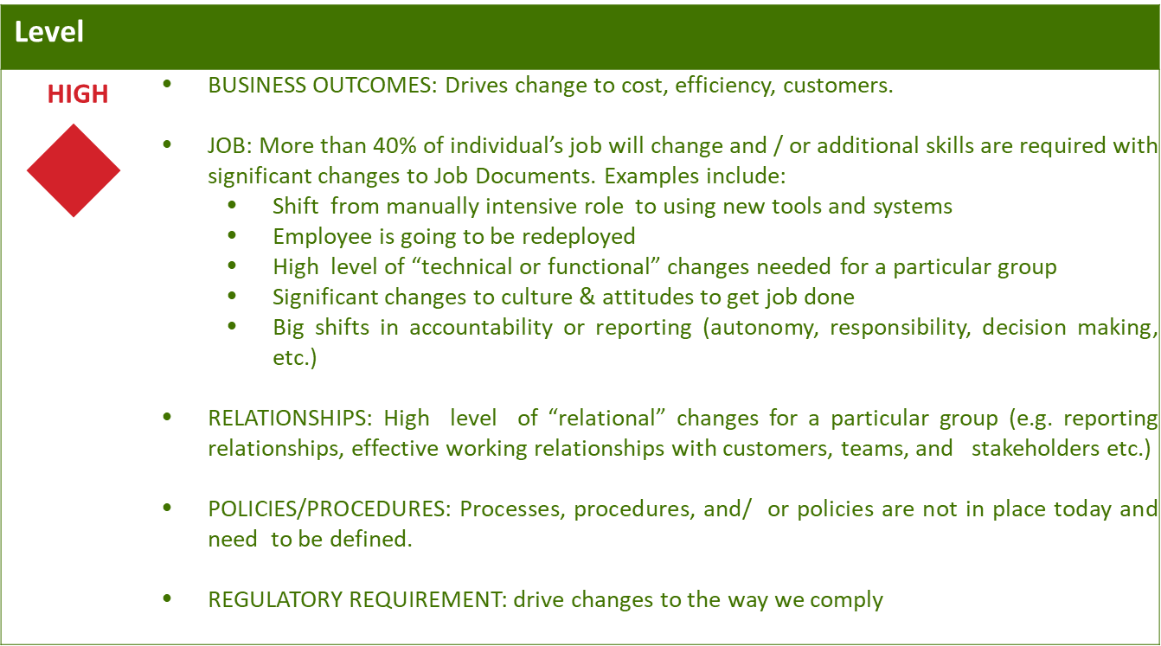
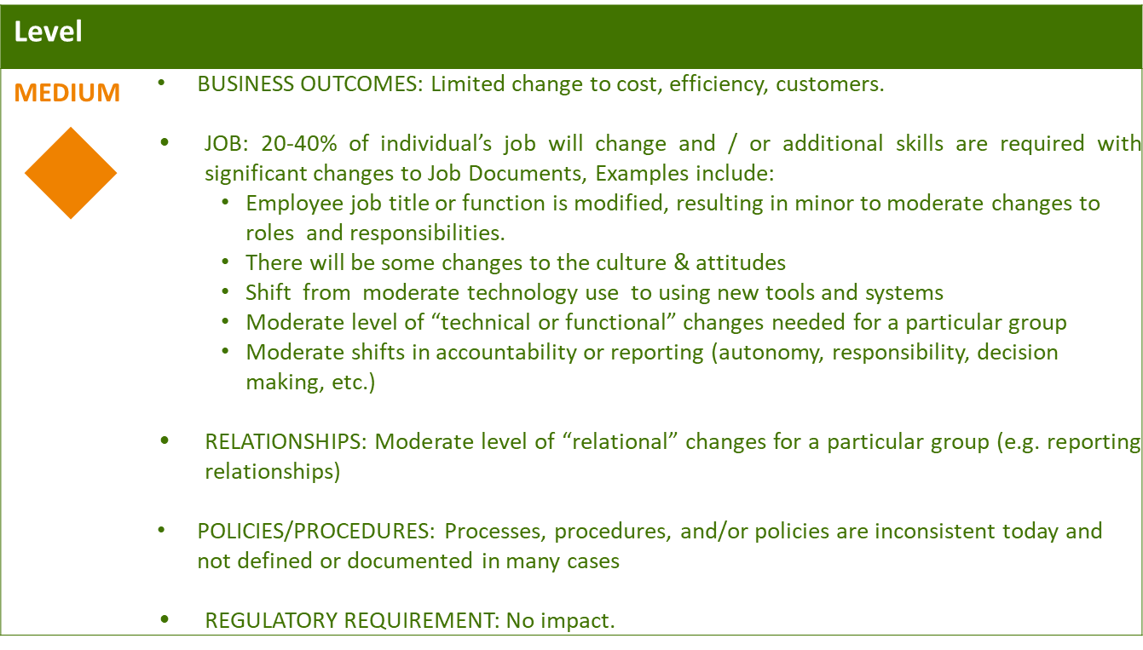
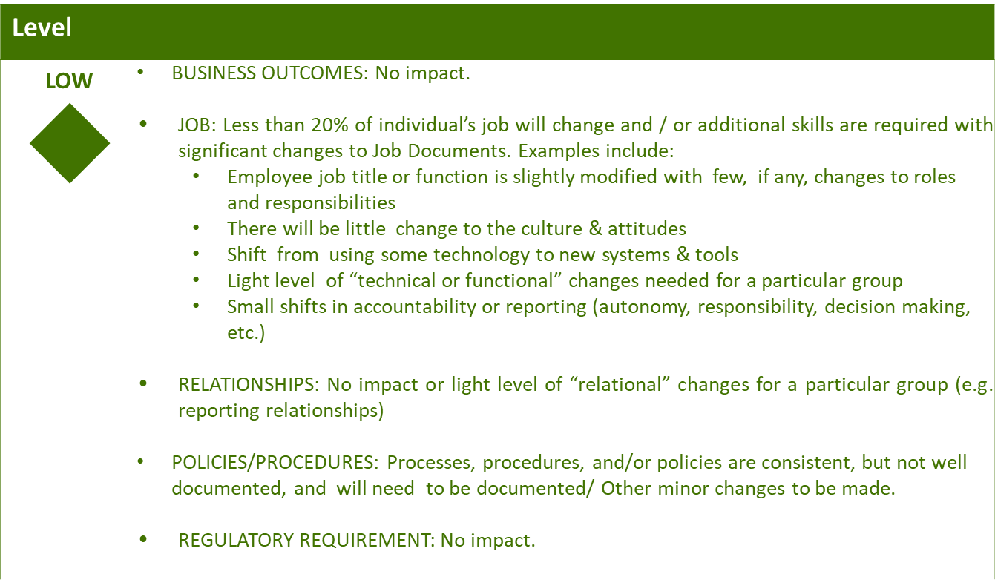

Business Effort: Initial assessment of the impact to the business High, Medium, Low

Requirements

Attachment

